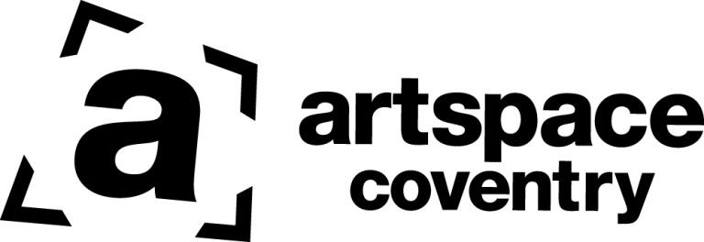
Temporary* Resident Membership Application
*Studios are usually allocated for a maximum 12 months or 18 months for dual occupancy. Artists can extend their occupancy for an additional year at an increased membership fee.
If you need help completing this form email space@coventry-artspace.co.uk with ‘Request Support’ in the subject title, or come along to one of our drop-ins 1pm-2.30pm on the first Thursday of each month.

Name: Postcode:
Telephone number:
Email:
Website / Social Media / online links:

- Describe your art in a few sentences making clear what materials you use and if you are able to work in a dry studio (maximum 250 words):

- Tell us what you hope to achieve from having a temporary studio with Coventry Artspace (maximum 250 words):

- Please tell us about any art training you’ve had including dates (if you have had extensive art training please just tell us about the main courses / qualifications)

- At what times would you need to have access to the studio space? (highlight all that apply)

Evenings Saturday am Saturday pm Sundays Weekdays

- Approximately how many hours a week (on average) would you expect to be able make use of a studio space?
...................

- Do you have any access requirements? (circle one) Yes / No If Yes, tell us about these here:

............................................................................................................................

- All studio members are expected to contribute occasional volunteer support to the Artspace studio holder community by:
- supporting each other
- contributing to the cleaning and maintenance of Artspace spaces
- attending and supporting Artspace events whenever they can
- Raising awareness of Artspace events and services to other artists in the city, eg through social media

Please tick this box to confirm you are happy to contribute in these ways

Please tell us in the box below of any particular skills that you would be willing to contribute as an occasional volunteer to support Artspace (eg invigilation of exhibitions / install of exhibitions / curation of exhibitions / support at events / photography / film making / marketing and media support / office admin support / fundraising support / building maintenance)

Any other information you’d like to add:

Signature:...................................................................... Date:....................................................…
Please send this form with at least 5 images of your work, or suitable web links that provide this*
Equal Opportunities

The section on the next page is about you. It’s a little personal but is really useful to us. The questions have been designed to align with the way the UK Government collects Census data. By answering these questions, you will help us to see how well we are serving everyone in our community.

Which of the following options best describes how you think of your gender identity?
(Tick one only) ❑ Male ❑ Female ❑ In another way ❑ Prefer not to say

Which of the following age groups do you belong to? (Tick one only)
❑ Under 16 ❑ 16 – 19 ❑ 20 – 24 ❑ 25 – 29 ❑ 30 – 34 ❑ 35 – 39 ❑ 40 – 44 ❑ 45 – 49 ❑ 50 – 54
❑ 55 – 59 ❑ 60 – 64 ❑ 65 – 69 ❑ 70 – 74 ❑ 75 – 79 ❑ 80 - 84 ❑ 85 or older ❑ Prefer not to say

What is your ethnic group? (Tick one only)
WHITE | MIXED | ASIAN OR ASIAN BRITISH | BLACK OR BLACK BRITISH | OTHER
❑ English / Welsh / Scottish / Northern Irish / British  ❑ Irish  ❑ Gypsy or Irish Traveller  ❑ Other White background | ❑ White and Black Caribbean  ❑ White and Black African  ❑ White and Asian  ❑ Other Mixed / multiple ethnic background | ❑ Indian  ❑ Pakistani  ❑ Bangladeshi  ❑ Chinese  ❑ Other Asian background | ❑ African  ❑ Caribbean  ❑ Other Black / African / Caribbean background | ❑ Arab  ❑ Other  ❑ Prefer not to say

Do you identify as a deaf or disabled person, or have a long-term health condition?
(Tick one only) ❑ Yes ❑ No ❑ Prefer not to say

Do you live overseas? ❑ Yes ❑ No
If you live overseas, what is your country of residence?…….………………………………………………………………..

Thank you for completing this form.
Please return it to us at: space@coventry-artspace.co.uk
or send it to: Coventry Artspace, Floor 4, Eaton House, 1 Eaton Road, Coventry CV1 2FJ

*Please note, if you are sending examples of your work via weblinks, please ensure these work well and do not require additional sign-ins.

