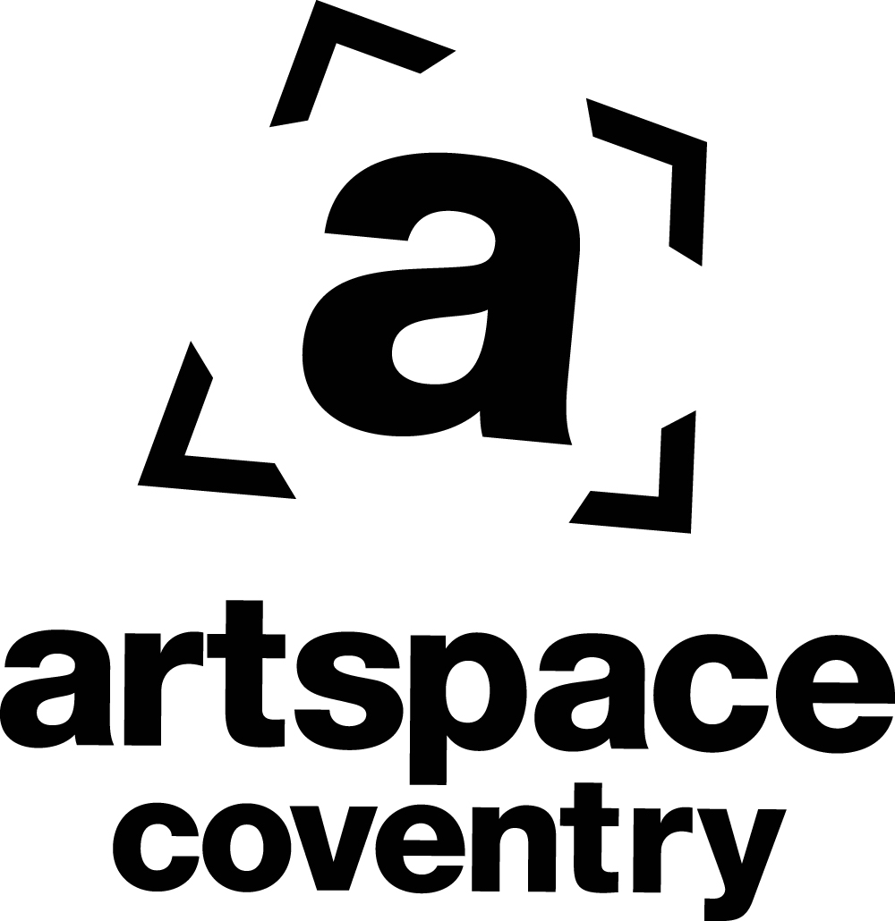

Arcadia

External Exhibition Proposals /Application Form

Lead Artists/Curators:

Contact email:

Contact telephone:

Project Please provide an outline of your exhibition/ project detailing aims and outcomes (maximum: 250 words):

Dates/Schedule Please include proposed dates of exhibition/event and duration including opening times(exhibitions may run to a maximum of one month) as well as dates and times needed for installation and get out:

Proposed size and number of works if known (indicative estimate):

Technical support Please indicate whether technical support will be required for installation, mounting, lighting; other requirements:

Budget / Funding Please indicate your budget and sources of funding (if applicable):

Signatures: Dates:

Please send up to 5 images of the intended works, or as an example of your work, along with the completed application form to: mail@coventry-artspace.co.uk or post to: City Arcadia Gallery, c/o Coventry Artspace Partnership, Floor 4, Eaton House, 1 Eaton Road, Coventry CV1 2FJ

Arcadia Directors’ Panel
Nicola Richardson, Artspace Trustee
Ryan Hughes, Artspace Trustee
Hannah Sutherland, Artspace Trustee
John Hammersley, Artspace Trustee

(Mindy Chillery, Executive Director)

DP Decision:
Accepted

Declined

Directors present:

Date:

